FFLogs Buff Allocation Math
by joncho#3796

This document outlines the calculations for the allocation of percent damage, crit, and DH buffs on FFLogs, as needed for the purpose of calculating various DPS metrics (currently aDPS, rDPS, and nDPS). These calculations are changing with Endwalker; I present the Endwalker results first, but the calculations used in Shadowbringers can still be found at the end of the document.
The equations and discussion presented here assume that a crit and/or direct hit buff may be present, but all equations are valid even when that is not the case – many parts of the equations will simplify when no crit and/or direct hit buffs are present.

Endwalker (and Beyond) Math

Standard Hits
First, consider a non-DoT hit of damage N. When a player has a crit or DH buff on them, we first address the fact that we do not know whether a crit and/or DH was a result of buff(s) or the player's natural stats. To handle this, we split each hit based on the probability that the crit and/or DH was natural or buffed.

Normal Hit (Neither a Crit nor a Direct Hit)
To start, consider the most basic situation. If a hit is neither a crit nor a direct hit, then crit and dhit buffs receive zero allocation, and we only need to consider percent damage buffs. First we calculate the damage gained from all external buffs. This is the damage gained from a buff of multiplier M. Where M is the total combined multiplier for all external percent buffs, equal to the product of all the individual percent buffs, m_{i}. Without this multiplier the hit would have done damage equal to $N' =N/M$. Where N is the actual in-game damage of the hit. This means that the damage gained from the buffs is $N-N/M$ or $N(1-1/M)$. We then split this damage among all the individual buffs via a log-ratio:
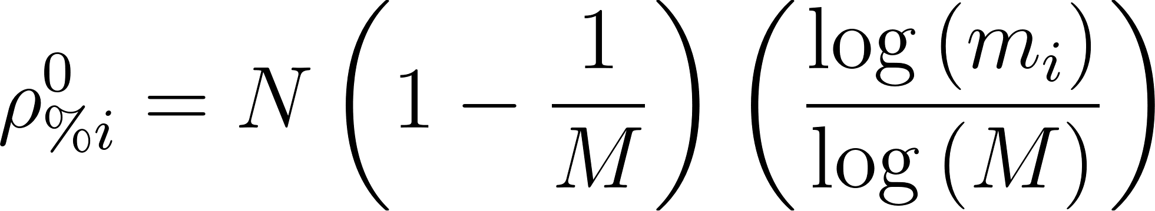
A log-ratio allocation is used here because it is conceptually clean to have multiple buffs, which combine to equal one other buff, split the damage equally. For example two 4.88% buffs will provide as much value as a single 10% buff ($1.0488*1.0488 = 1.10$). In a log-ratio split, the two 4.88% buffs combined will take as much credit as the single 10% buff ($log(1.0488)+log(1.0488) = log(1.0488*1.0488) = log(1.10)$) because of the logarithmic property $log(A) + log(B) = log(A*B)$. So if an event has three buffs applied to it, one 10% buff and two 4.88% buffs, then the rDPS buff contribution will be split out as 1/4 to each of the 4.88% buffs and 1/2 to the 10% buff.

Critical Hit
For any hits that are a critical and/or direct hit, we must account for the presence of crit and dhit buffs. Consider a player with a stat-given crit rate of C_{s} and direct hit rate of D_{s}, and buffed crit and direct hit rates, C_{b} and D_{b}, respectively. We also want to account for self-given buffs, since self-buffs are excluded from the multiplicative gains of buff stacking. We will absorb any self-given crit and dhit buffs into what will be called a player’s “unbuffed” crit rate, C_{u}, which includes both the player’s stat-given crit rate and any self-buffs: $C_{u}=(C_{s}+C_{selfBuffs})$. Similarly a player’s “unbuffed” direct hit rate is defined as: $D_{u}={(D}_{s}+D_{selfBuffs})$.
If a hit is a critical, then we split the hit into two parts by multiplying it either by the likelihood that the crit was caused by the player's self-attained rate, 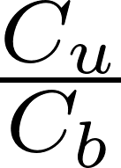, or by a buff, 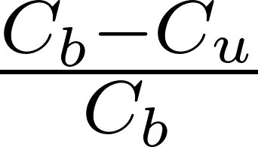. Now we want to look at each piece individually.
For the unbuffed part, we treat the crit multiplier, M_{C}= 1.35+C_{s}, as a "self buff". This means that the crit multiplier does not take part in the multiplicative buff sharing. While for the buffed part, the crit multiplier acts as an external buff given by the buffing player, so the buffer will be attributed rdps as if they had provided a % buff equal to M_{c}.
If this player had both percent buffs and crit buffs, the rdps allocation would be split as follows (since this hit did not direct hit, even if there was a direct hit buff on the player, the rdps contribution would just be 0). The unbuffed crit part of the hit will have no rdps given to the crit buff, so that just leaves percent buffs to receive their rdps allocation as normal:
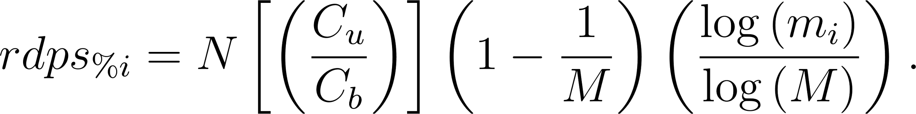
For the buffed part, we have both an rdps allocation for the percent buffs as well as the crit buffs. The crit buff allocation is further split among all the players which provided a crit buff, proportionally to the likelihood their buff would have granted the crit, where C_{i} are the individual crit buffs:
The total rdps portions for this hit are the sums of the corresponding contributions for each part (the superscript denotes the type of hit):

Direct Hit
For a direct hit only hit, the math proceeds similarly, with $M_{D}=1.25$ and D_{i} being the individual direct hit buffs:

Critical Direct HIt
For a crit direct hit, we need to split the hit into four pieces based on the likelihood of: 1) both the crit and dhit coming from buffs, 2) the crit coming from buffs and the dhit being unbuffed, 3) the crit being unbuffed and the dhit coming from buffs, and 4) both the crit and dhit being unbuffed. The math is a little more involved, but it proceeds similarly.
For part 1, 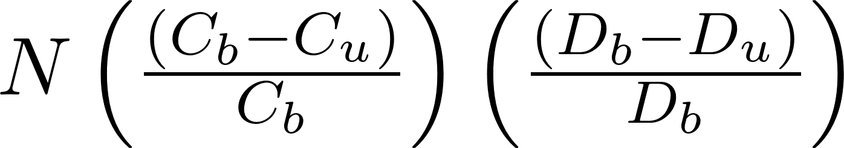, the rdps allocations are:

For part 2,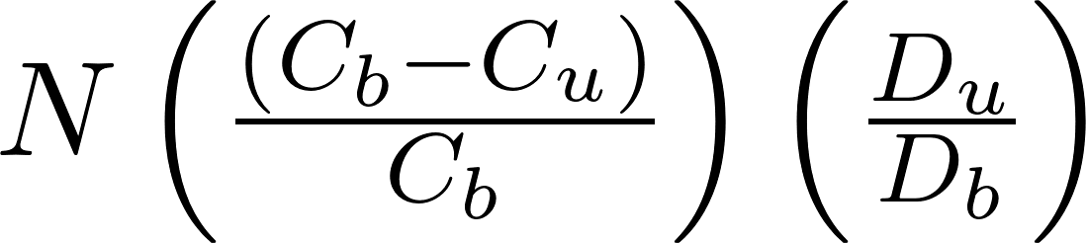, the rdps allocations are:

For part 3, 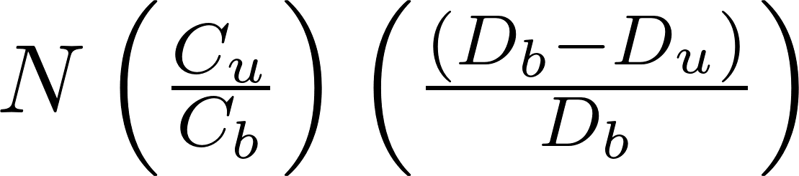, the rdps allocations are:

For part 4, 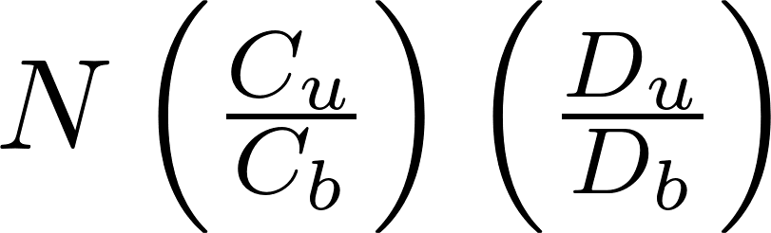, the rdps allocations are:
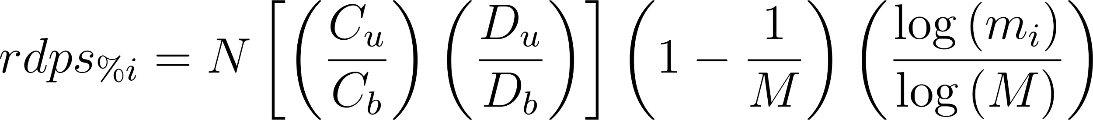

This makes the total rdps portions of a crit direct hit:
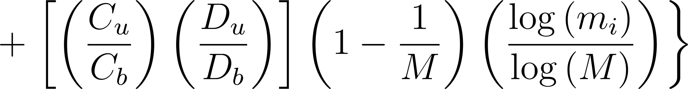

Auto-critical and/or auto-direct hits
In the case an event is guaranteed to be a critical and/or a direct hit via a job-internal mechanic, for the purposes of this math, those hits will be treated as if they did not crit and/or dhit, respectively. So a guaranteed critical direct hit will be treated as a “Normal Hit”, as all critical and dhit buffs have no effect on it; a guaranteed critical event that ends up being a critical direct hit will be treated only as a direct hit, as all crit chance buffs will have had no effect; and so on.

Addition for Patch 6.2:
In patch 6.2 FFXIV added a feature where crit and dhit rate buffs now apply a percent damage buff to abilities that automatically crit or dhit, respectively. This appears to be implemented as a single multiplier for crit buffs and a single multiplier for dhit buffs based on the total buff to the rate, as such:
where 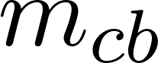 and 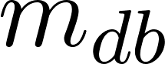 are the multipliers associated with crit buffs and dhit buffs, respectively.
However, as usual we want to remove self-buffs from any multiplicative gains, so FFLogs will consider the multiplier from external-only crit or dhit buffs, which is determined by the ratio of the total crit or dhit multiplier from above to the would-be multiplier if only self-buffs were present (recall that self-given crit and dhit buffs are already absorbed into  and , respectively):
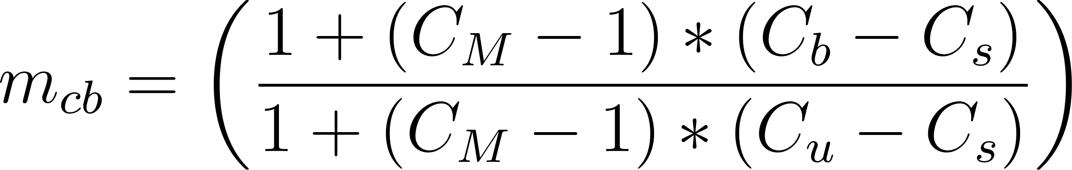
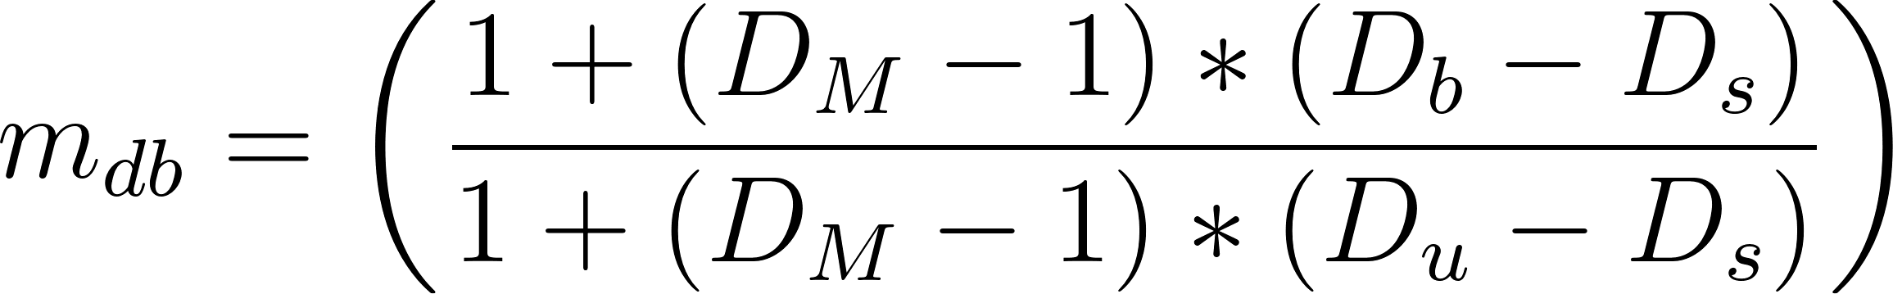

The pre-6.2 paragraph is still true, except that this additional buff multiplier is also accounted for. So an auto-crit and/or dhit is still treated as if it did not crit and/or dhit, respectively, but an additional 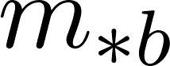 for the collection of external crit buffs and/or the collection of external dhit buffs is added to the collection of buff multipliers present. This means that for:
an auto-crit and dhit ability, 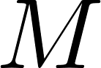 gets replaced by 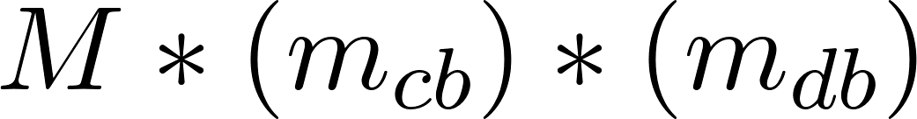,
an auto-crit ability,  gets replaced by 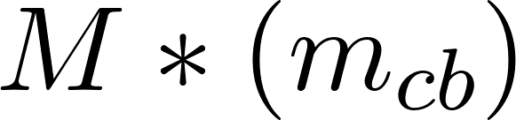,
and
an auto-dhit ability,  gets replaced by 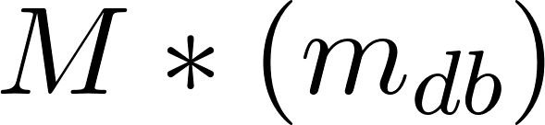
The contributions attributed to  and  -- call these 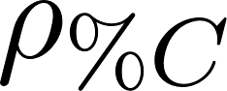 and 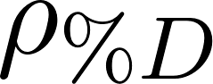 -- are then calculated in the same way as for any normal 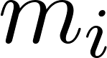, which is to say either via 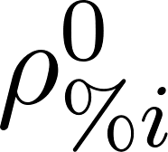, 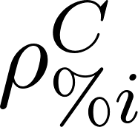, or 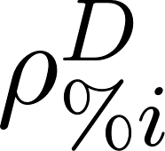 depending on the situation. Finally, this contribution is split out to the individual buffers. Since this multiplier is based on the sum total rate buff present, the total contribution from buff multipliers is not split out to the individual buffs through a log ratio, as many other aspects of the rDPS math do, but are instead split based on the ratio of an individual rate buff's contribution to the total rate buff:
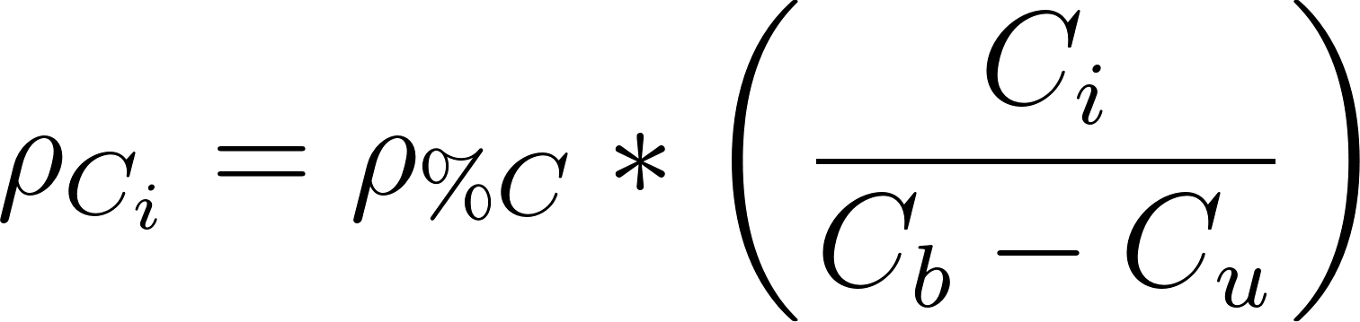
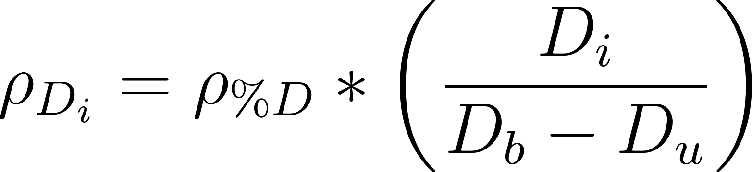

DoT Events
Now consider DoT damage. Since DoT damage is an aggregated average of crit and dhit events, we cannot apply only one of the above calculations. Instead, we apply the probabilistic sum of all the above, based on the chance that DoT damage might be a crit, dhit, both, or neither. So, the portion of rdps allocations becomes:
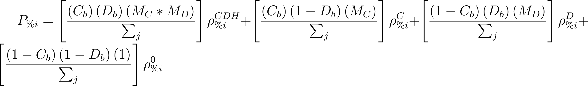
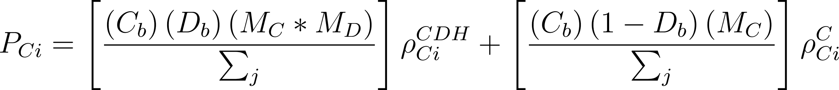
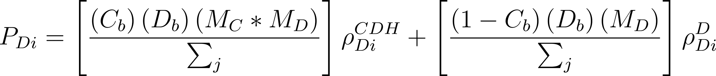
Where $ρ_{\%i}^{0}$ just represents the portion of a hit typically given to a percent buff when no crit or dhit buffs are present, and  is the normalized total aggregate damage:

Shadowbringers Math

Standard Hits
We only look at standard hits for Shadowbringers because the current DoT equation doesn’t change, just insert the ρ’s presented below. Similarly, the math surrounding a “Normal Hit” hasn’t changed, so it is not presented again.
Again consider a non-DoT hit of damage N, and we will consider how to handle this for the cases of the event being a crit, dhit, both, or neither.

Critical Hit
Let's start with a critical hit event. Begin by finding the critical portion of this event:
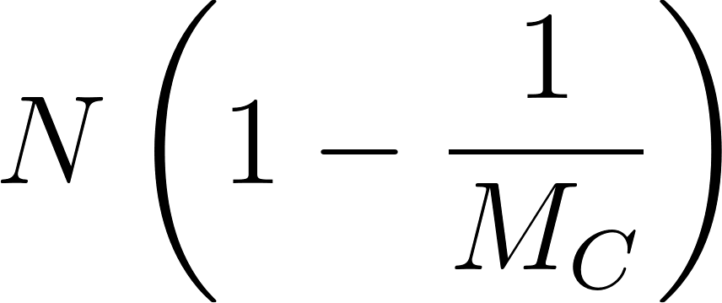
Since we do not know whether this crit was the result of buffs or the player's natural crit rate, we attribute part of this portion to crit buffs equal to the likelihood that the crit was caused by the crit buff, 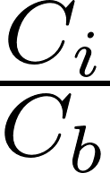, and the remainder, , is considered unaffected by crit buffs. Note that if the event is an auto-crit, then the whole of the crit portion is treated as a natural crit.
While we now have a part attributed to the crit buff, we still need to extract part of that for percent buffs. To do this, we take a portion of the hit based on our standard logarithmic splitting, in which we treat  and  as the multiplier present on this portion of damage. This gives us a contribution to percent buffs from this crit buff portion equal to:
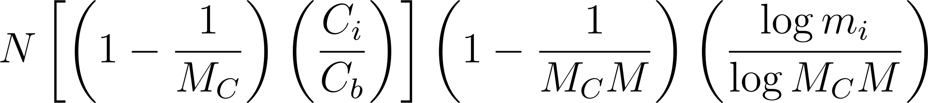
This is done for all percent buffs present, and the crit buff is allocated the remainder. This is the full allocation for the crit buff:
(Note that )
We now need to finish collecting the contributions to the percent buff allocations. We calculated earlier the percent buff contribution from a single crit buff portion, in the case of multiple crit buffs being present, the total contribution by a percent buff from all crit buff portions is:

(Note that 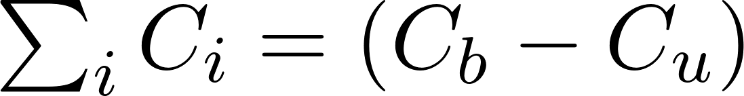)
Consider now the natural crit portion of the overall crit portion, 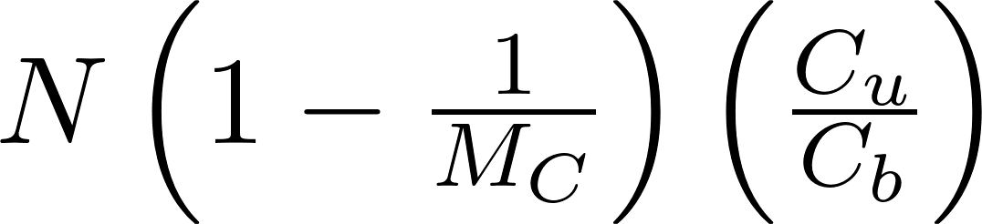. We get the percent buff allocation from this portion thought the standard logarithmic splitting with only  present for buffs:
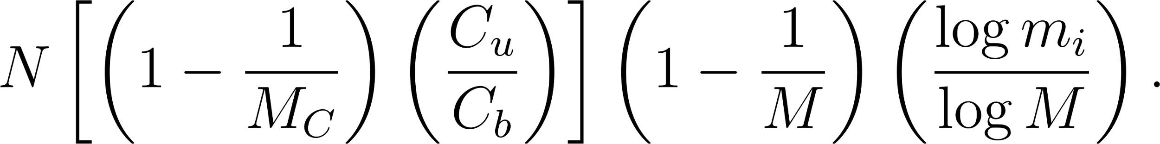
Finally, consider the non-crit portion of the hit, 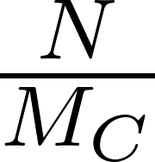. We also get the percent buff allocation from this through the standard logarithmic splitting:
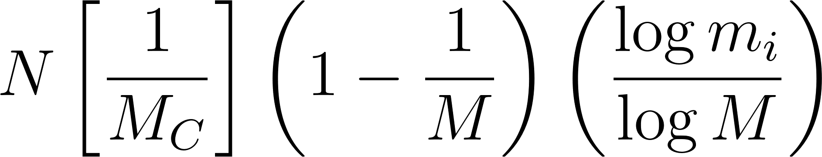
The total percent buff allocation is the sum of these contributions:

Direct Hit
Direct hits proceed similarly, with a direct hit portion being divided into direct hit buff portions and a natural direct hit portion, and then percent buffs being given part of each. This gives:

Critical Direct Hit
Crit Direct Hit events also proceed quite similarly, aside from an adjustment to the initial assignment of the crit portion and the direct hit portion. We treat  and  as shared multipliers here, and split them logarithmically as usual. These are now:
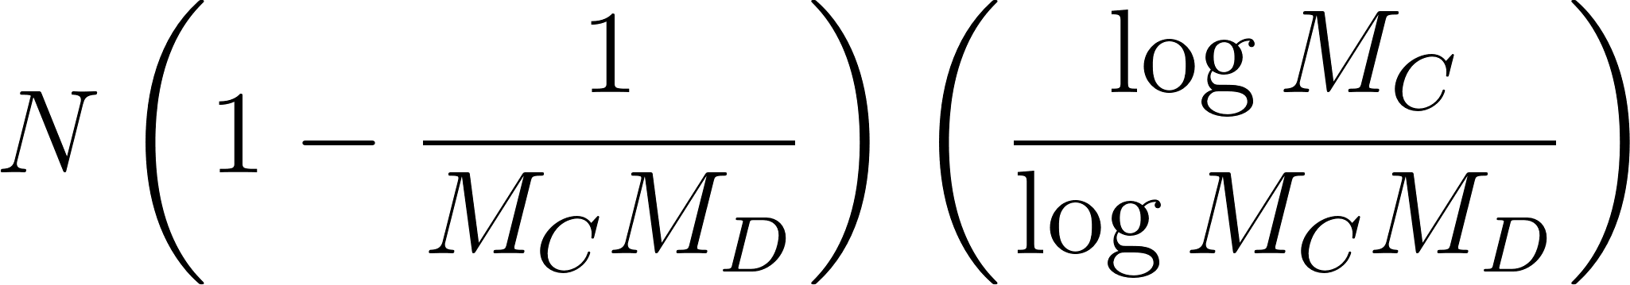
and
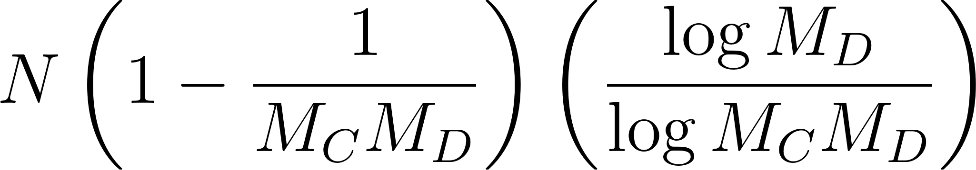
for the crit and direct hit portions, respectively. Again, note that if the event is an auto-crit, then the whole of this crit portion will be treated as a natural crit, and similarly for auto-direct hits and the direct hit portion.
The crit and dhit portions are now treated just as they were before, giving:

The percent buff allocation also proceeds the same, though it now has more terms, as it includes the sum of allocations from all the crit buff portions, all the direct hit buff portions, the natural crit portion, the natural direct hit portion, and the non-crit non-direct hit portion. This gives:

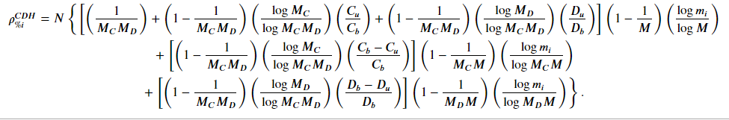

Changelog
- October 21, 2022 - Included the update to auto-crit and dhit abilities introduced as a result of the game changes in Patch 6.2
- December 9, 2021 - Included handling for self-given crit and dhit buffs
- November 22, 2021 - Updated to represent changes taking effect in Endwalker, with Shadowbringers math left in for documentation
- January 26, 2021 - Added explanation to the “Actual FFLogs ρ Formulae (Probably)” section
- November 11, 2020 - Added comments and a section on my best guess at the actual current FFLogs calculations
- October 28, 2020 - Updated DoT formula to accurately represent portions of the damage that are expected to be a crit, dhit, both, or neither.
- September 27, 2020 - Published, with thanks to Radrauser for pointing out typos

